# Diabetes Classification Results using AdaBoost

## Classification Report:

precision recall f1-score support  
  
 0 0.77 0.69 0.73 146  
 1 0.73 0.80 0.76 154  
  
 accuracy 0.75 300  
 macro avg 0.75 0.75 0.75 300  
weighted avg 0.75 0.75 0.75 300

## ROC AUC Score:

ROC AUC Score (AdaBoost): 0.8336817292296744

## ROC Curve:

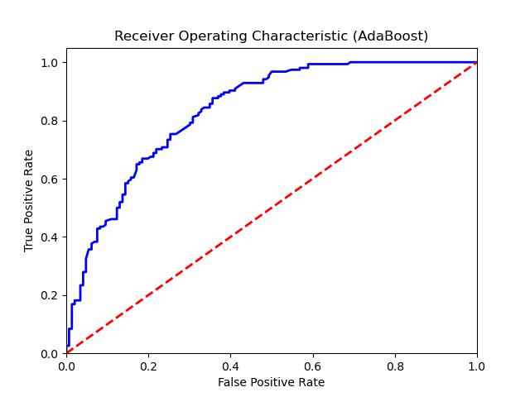

## Confusion Matrix:

True Negatives: 101

False Positives: 45

False Negatives: 31

True Positives: 123

## Confusion Matrix Plot:

